Date | 3 October 2026
Project Name | Automated Network Request Management
Maximum Marks | 4 Marks
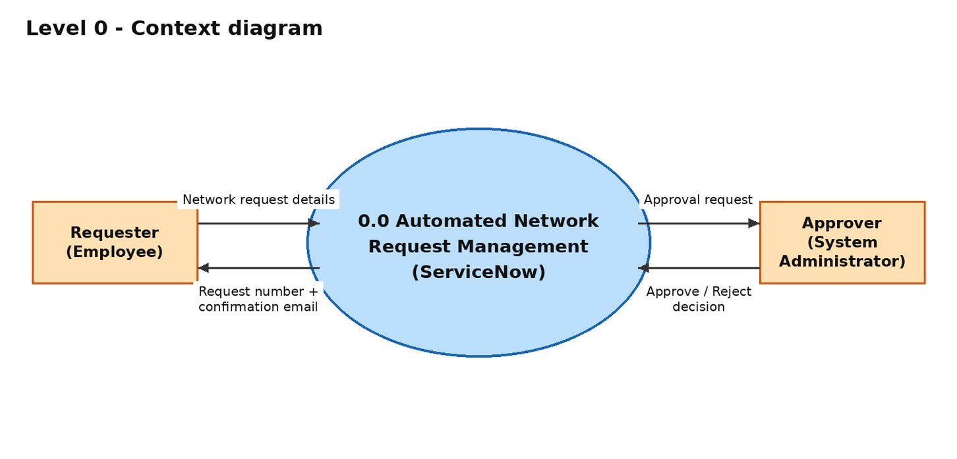
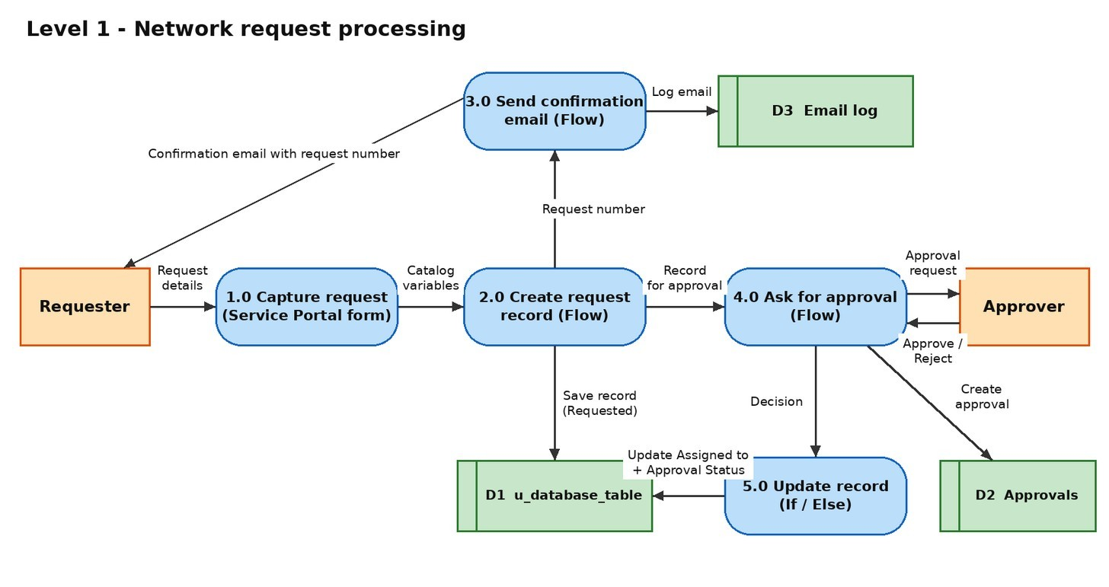
Project Design Phase-II Data Flow Diagram & User Stories
Data Flow Diagrams:
A Data Flow Diagram (DFD) is a traditional visual representation of the information flows within a system. A neat and clear DFD can depict the right amount of the system requirement graphically. It shows how data enters and leaves the system, what changes the information, and where data is stored.
DFD Level 0: (Context diagram) DFD Level 1: Network Request Process
User Stories
Use the below template to list all the user stories for the product.
User Type | Functional  Requirement  (Epic) | User  Story  Number | User Story / Task | Acceptance criteria | Priority | Release
Requester (Employee) | Request submission | USN-1 | As a requester, I can open the Network Request item on the Service Portal and fill in the request form. | The form opens with all 7 variables and mandatory fields are enforced | High | Sprint-1
 |  | USN-2 | As a requester, I can choose the Type of Connection (New or Existing) and see the Existing ID field only when I choose Existing. | The "Enter your existing id" field is visible only for Existing | Medium | Sprint-1
 | Requester information | USN-3 | As a requester, I want my email, user name and phone number filled in automatically when I select Opened on behalf of. | Email, user name and phone populate from the selected user | Medium | Sprint-1
 | Request confirmation | USN-4 | As a requester, I receive a request number after I click Order Now. | The Request Summary page shows a REQ number | High | Sprint-2
 |  | USN-5 | As a requester, I receive a confirmation email that contains my request number. | The email appears in System Logs > Emails with the request number | Medium | Sprint-2
Approver  (System  Administrator) | Approval | USN-6 | As an approver, I can see the pending approval for each network request. | The approval shows under My Approvals and in the record's Approval Request related list | High | Sprint-2
 |  | USN-7 | As an approver, I can approve or reject the request. | The decision is recorded and the flow continues | High | Sprint-2
Administrator | Request tracking | USN-8 | As an administrator, I can see every request in the Database Table with its Approval Status and Assigned to. | Approved: Assigned to = ITIL User, status  Approved. Rejected: Assigned to =  Abraham Lincoln, status Rejected | High | Sprint-2
 | Maintenance | USN-9 | As an administrator, I can maintain the automation in Flow Designer without custom scripts. | The flow is Active and every run is visible in Flow Executions | Medium | Sprint-3
Network team member | Fulfilment visibility | USN-10 | As a network team member, I can view approved requests with full details so I can act on them. | Approved records show requested for, mobile number, connection type and address | Medium | Sprint-3

